Emotion Recognition from Face (Updated with CNN Explanation)

1. Introduction to CNN (Convolutional Neural Network)

What is CNN?
A Convolutional Neural Network (CNN) is a type of Deep Learning model specially designed to process image data. Unlike traditional neural networks that treat input as flat numbers, CNN understands spatial relationships between pixels.
In simple terms: - Normal Neural Network → Treats image as random numbers - CNN → Understands patterns like edges, shapes, textures, eyes, mouth, etc.
CNN is inspired by the human visual cortex, where different layers detect different visual features.
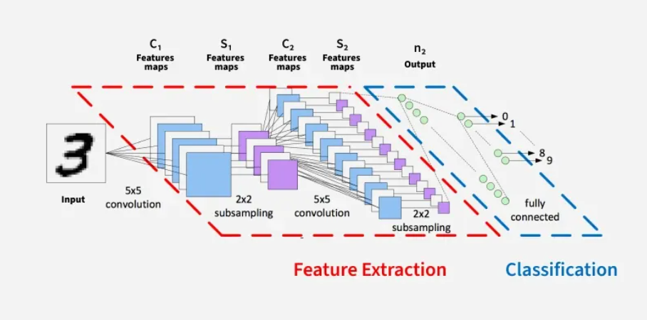

2. Why CNN is Used in Emotion Recognition
In this project, the input image size is 48x48 pixels.
If we use a normal neural network: 48 × 48 = 2304 input values.
It cannot understand which pixels are close to each other.
But CNN: - Preserves spatial structure - Detects facial features - Learns patterns automatically
Emotion detection depends heavily on: - Mouth curve (smile or frown) - Eyebrow position - Eye openness - Facial wrinkles
CNN automatically learns these important features without manual programming.
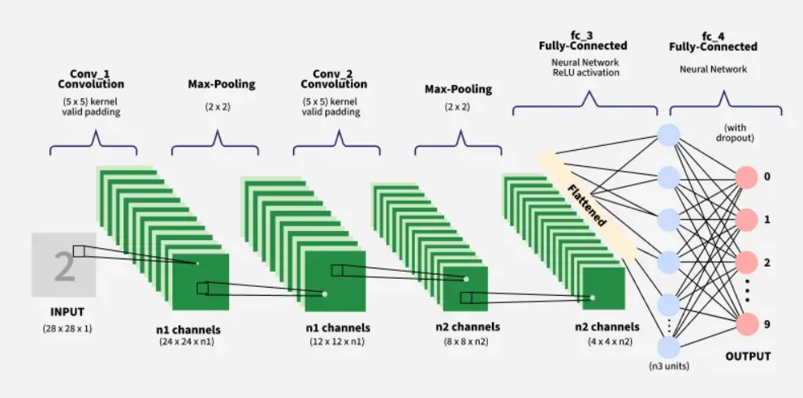

3. Why CNN is Efficient

1. Parameter Sharing (Weight Sharing)
CNN uses filters that slide across the image. The same filter is reused everywhere.
This reduces the number of parameters.
Benefits: - Faster training - Less memory usage - Reduced overfitting

2. Automatic Feature Extraction
Without CNN, we would need to manually design: - Edge detectors - Facial landmark extractors - Texture analyzers
CNN learns all these automatically during training.

3. Hierarchical Learning
Layer 1 → Detects edges Layer 2 → Detects shapes Layer 3 → Detects facial parts Final layers → Detect emotion patterns
This makes CNN extremely powerful for image classification tasks.

4. How CNN Works in This Project
After preprocessing, we get a 48x48 grayscale image.

Step 1: Convolution Layer
A small filter (for example 3x3) slides over the image. It extracts features such as: - Vertical edges - Horizontal edges - Corners
Output → Feature Map

Step 2: ReLU Activation
Formula:
f(x) = max(0, x)
Purpose: - Removes negative values - Adds non-linearity - Helps model learn complex patterns

Step 3: Pooling Layer
Commonly MaxPooling (2x2).
Reduces image size: 48x48 → 24x24
Benefits: - Reduces computation - Prevents overfitting - Keeps important features

Step 4: Multiple Convolution + Pooling Layers
As layers increase: - Low-level features → edges - Mid-level features → eyes, nose - High-level features → full face patterns

Step 5: Flatten Layer
Converts 3D feature maps into a 1D vector.
Example: (6 x 6 x 128) → 4608 neurons

Step 6: Fully Connected Layer
Combines extracted features. Learns how different features relate to emotions.

Step 7: Softmax Output Layer
Outputs probability for each emotion class:
Happy → 0.72 Sad → 0.05 Angry → 0.08 Fear → 0.03 Surprise → 0.06 Neutral → 0.04 Disgust → 0.02
Highest probability = Predicted Emotion

5. CNN Implementation (Basic Example in Keras)
import tensorflow as tf
from tensorflow.keras.models import Sequential
from tensorflow.keras.layers import Conv2D, MaxPooling2D, Flatten, Dense, Dropout
model = Sequential()
# First Convolution Block
model.add(Conv2D(32, (3,3), activation='relu', input_shape=(48,48,1)))
model.add(MaxPooling2D((2,2)))
# Second Convolution Block
model.add(Conv2D(64, (3,3), activation='relu'))
model.add(MaxPooling2D((2,2)))
# Third Convolution Block
model.add(Conv2D(128, (3,3), activation='relu'))
model.add(MaxPooling2D((2,2)))
# Flatten
model.add(Flatten())
# Fully Connected Layer
model.add(Dense(128, activation='relu'))
model.add(Dropout(0.5))
# Output Layer
model.add(Dense(7, activation='softmax'))
model.compile(
optimizer='adam',
loss='categorical_crossentropy',
metrics=['accuracy']
)
model.summary()

6. Model Performance Expectations
Basic CNN → 60–70% accuracy Improved CNN → 70–75% Transfer Learning → 75–85% (depends on tuning and dataset balance)

7. Interview Explanation (Important)
If asked: Why did you use CNN?
Answer:
CNN is used because it preserves spatial relationships in images, automatically extracts hierarchical features such as edges and facial patterns, reduces parameters using weight sharing, and performs significantly better than traditional neural networks for image classification tasks.

8. Final Understanding
By using CNN in this project, we: - Understand deep learning architecture - Learn real-time image processing pipeline - Apply mathematical concepts like gradient descent and cross-entropy - Build an industry-level computer vision project
This makes the project strong for resume and interviews.

End of Updated CNN Detailed Section.

